# INTRODUCTION

* + - Overview

CRM APPLICATION THAT HELPS TO BOOL A VISA SLOT

A visa slot management project is a system that is used to track and manage the availability of visa slots, which are appointments that are required for certain visa applications. It might be used by a government agency or a visa processing center to schedule and manage appointments with applicants.

* + - Purpose

A visa slot management project is a system that is used to track and manage the availability of visa slots, which are appointments that are required for certain visa applications.

1. **Problem Definition & Design Thinking**
   1. Empathy Map

Paste the empathy map screenshot

* 1. Ideation & Brainstorming Map

Paste the Ideation & brainstorming map screenshot.

# RESULT

* 1. Data Model:

|  |  |
| --- | --- |
| **Object name** | **Fields in the Object** |
| obj1-Passport | |  |  | | --- | --- | | Field label | Data type | | Contact Number | Number | | Contact Number | Number | |
| obj2-Visa | |  |  | | --- | --- | | Field label | Data type | | Passport Number | Master Relationship | | Passport Number | Master Relationship | |

# Activity & Screenshot

Attach the screenshots of your project activity along with the description.

Report 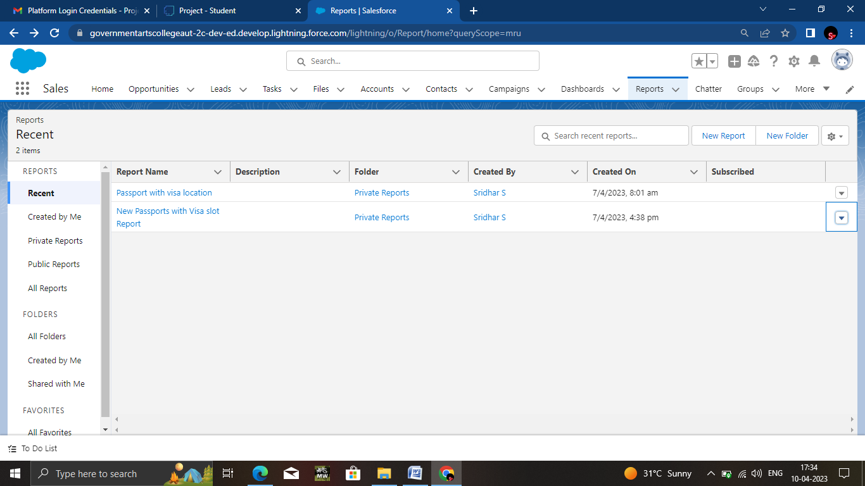

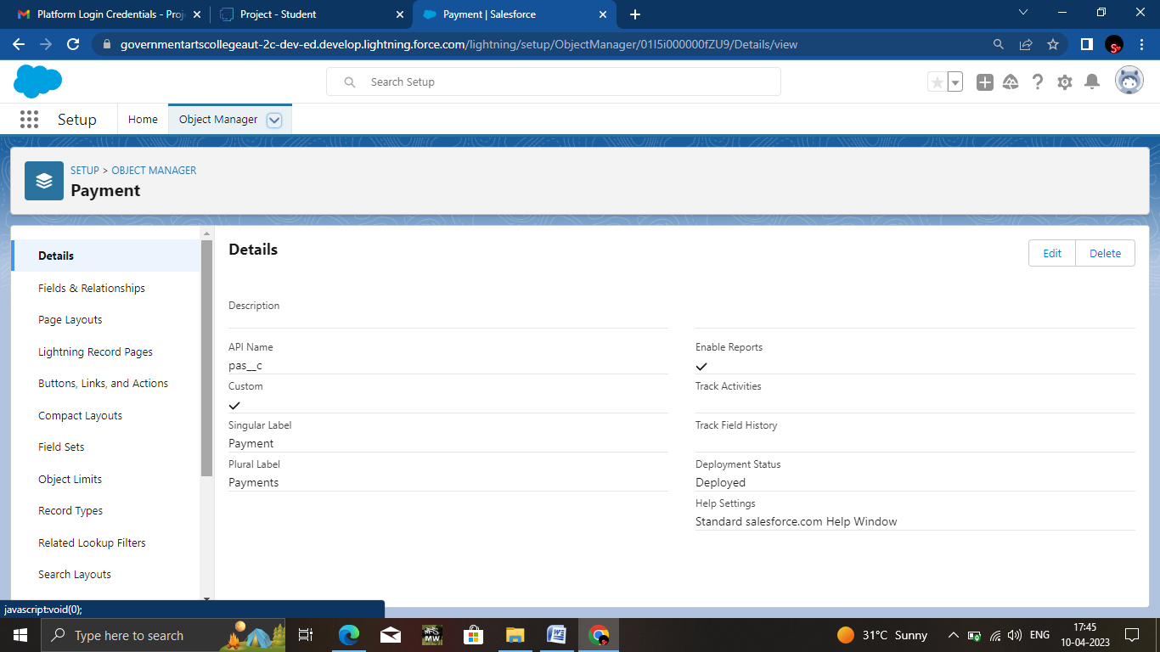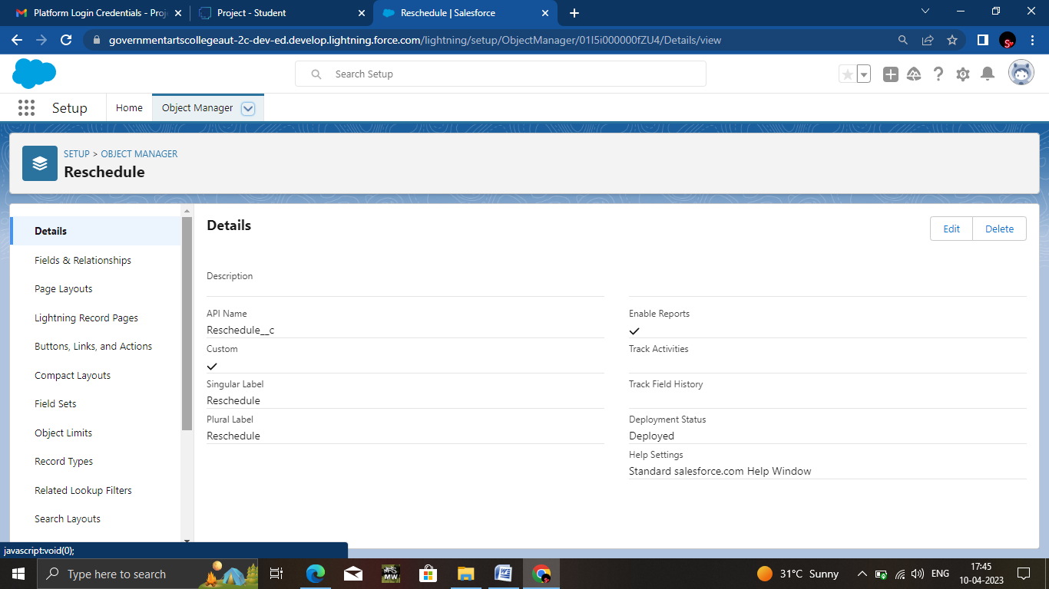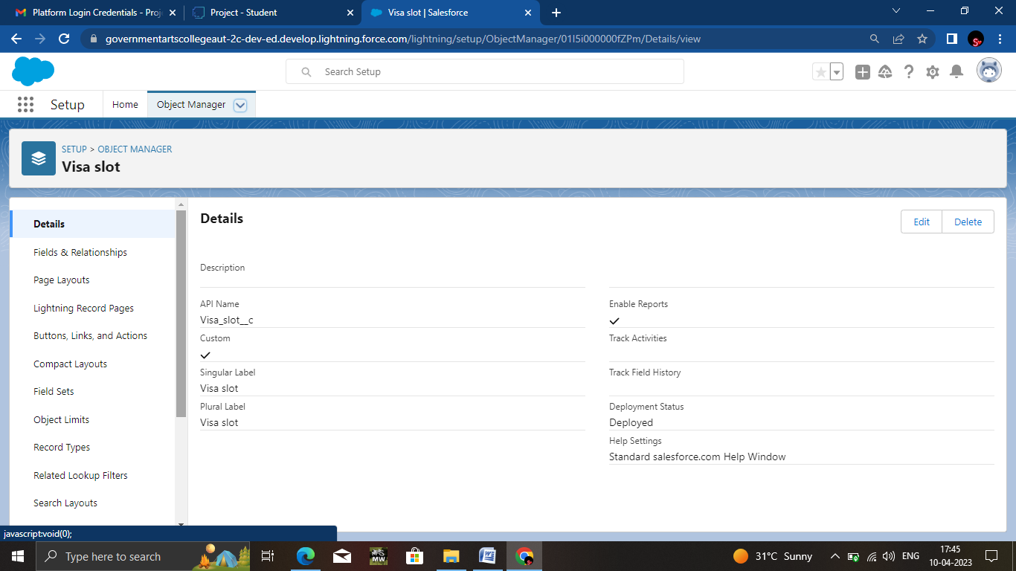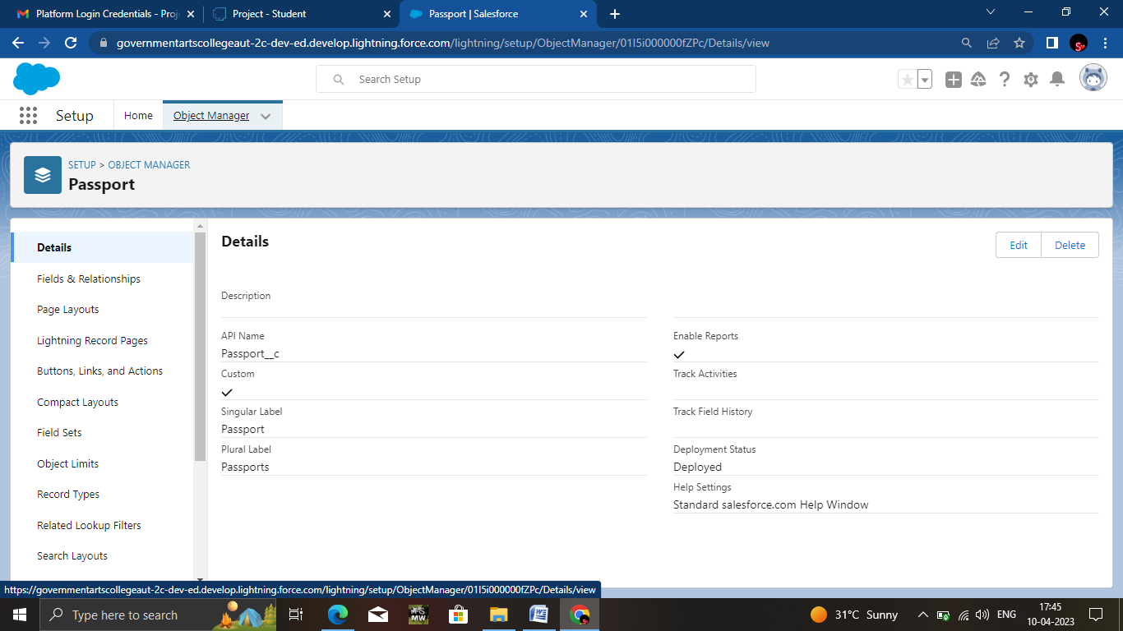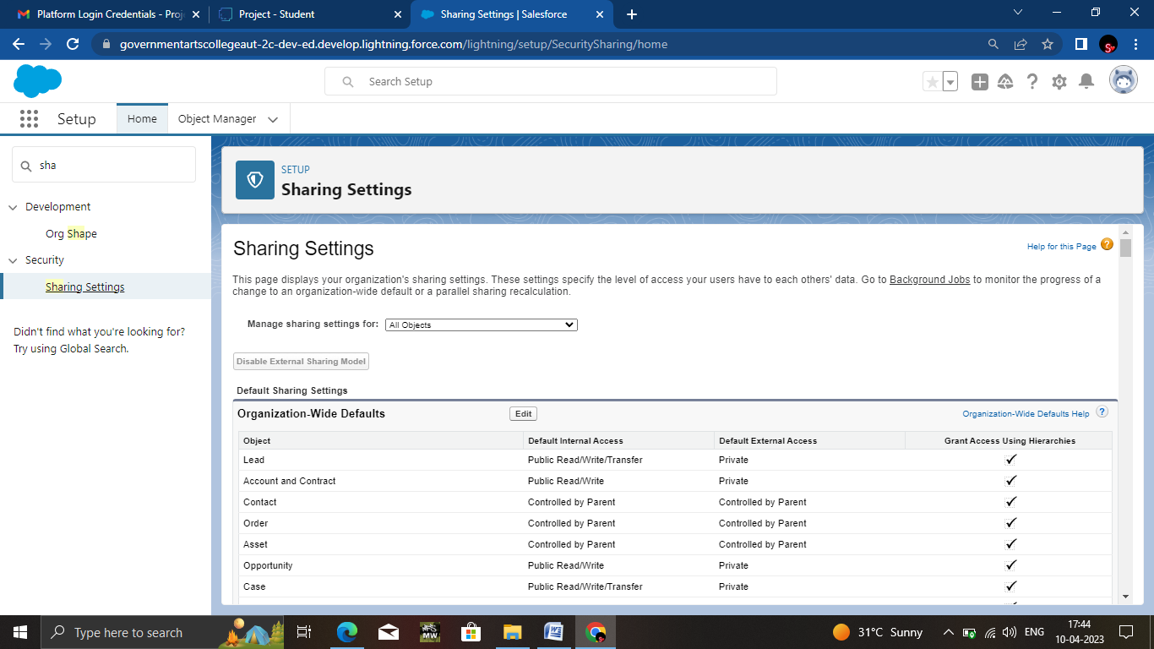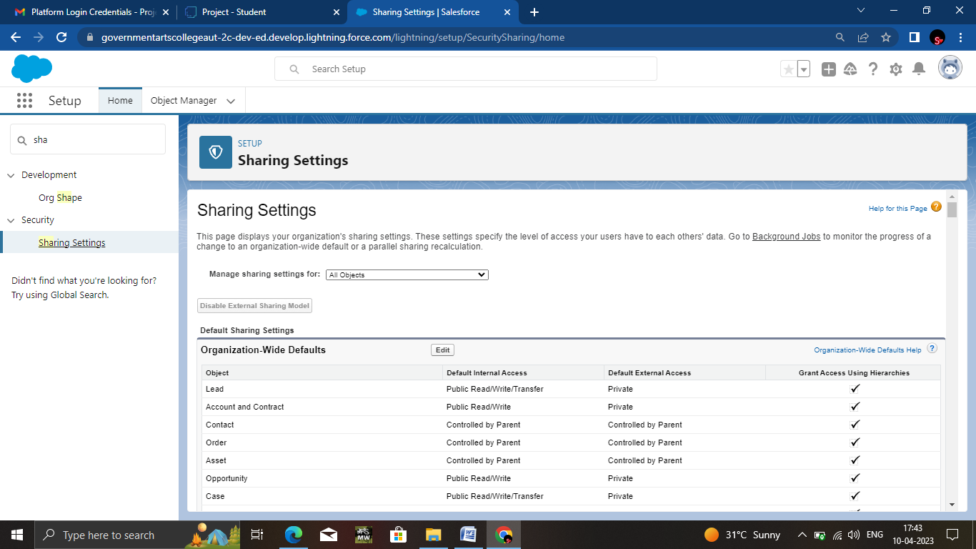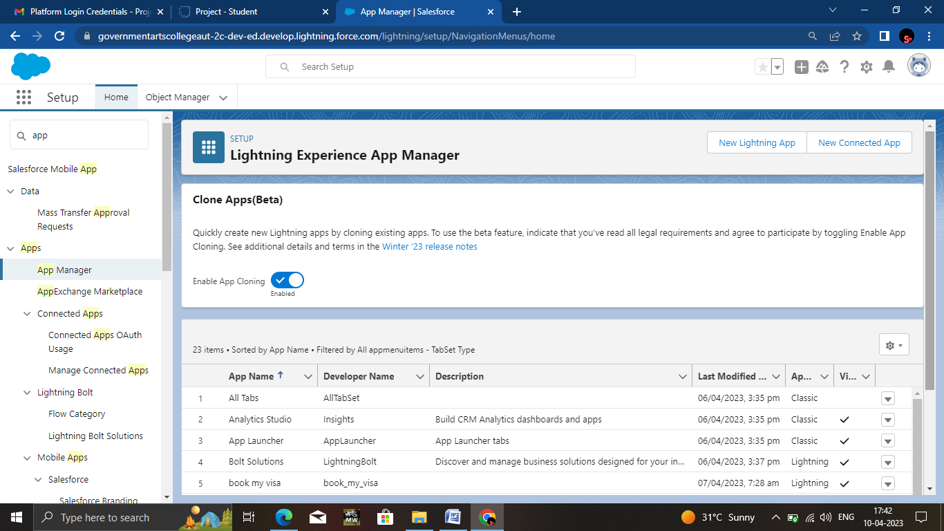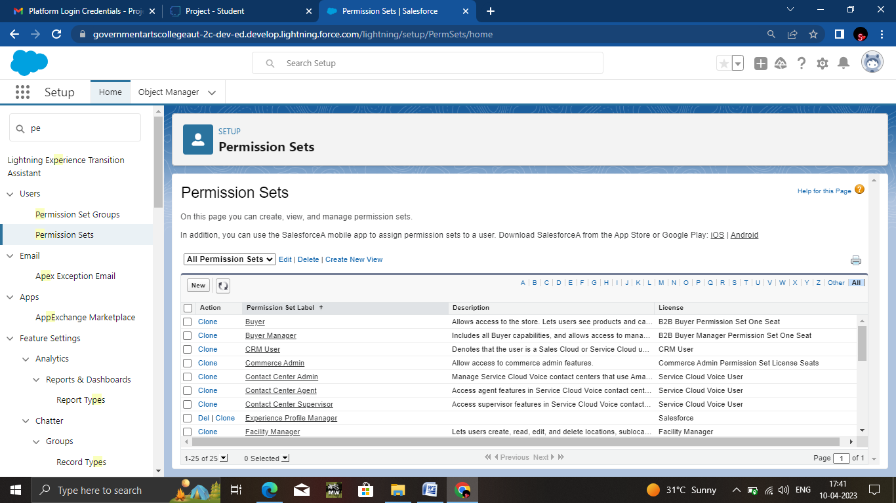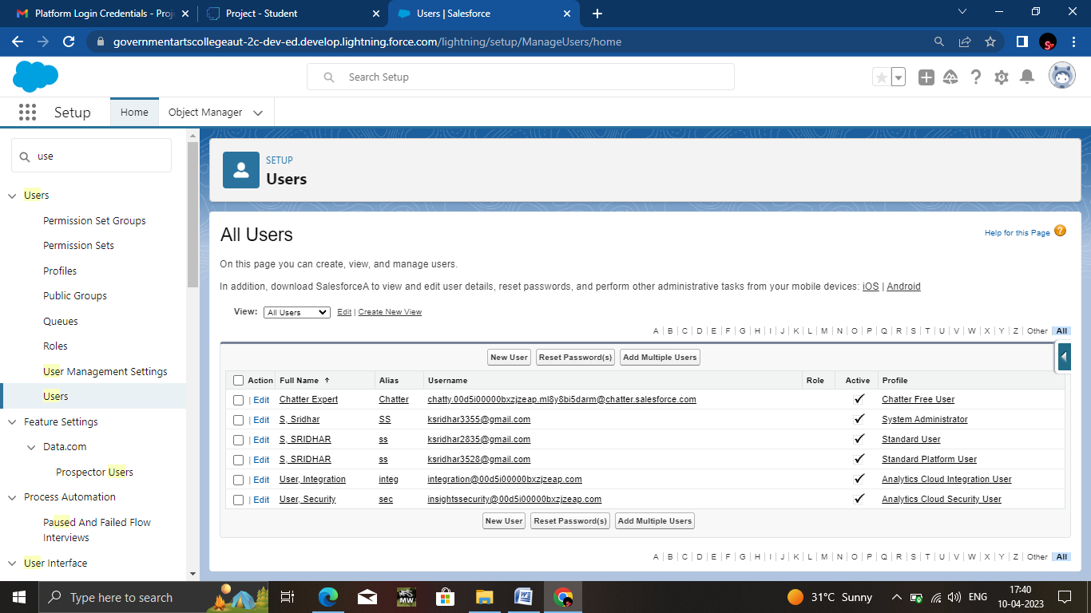

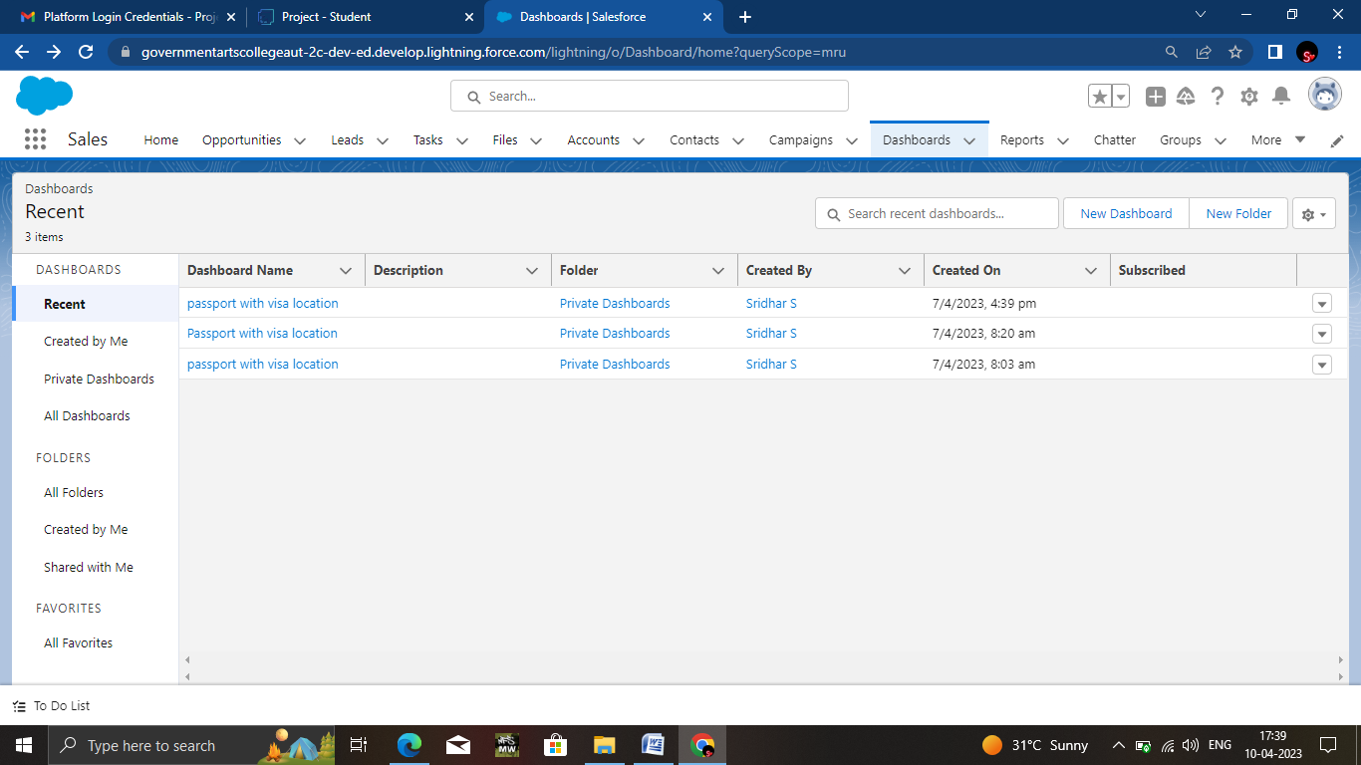

# Trailhead Profile Public URL

**Team Lead -** [**https://trailblazer.me/id/ssr77**](https://trailblazer.me/id/ssr77)

**Team Member 1-** [**http://trailblazer.me/id/ssu78**](http://trailblazer.me/id/ssu78)

**Team Member2-**

**https://trailblazer.me/id/thaga79**

**Team Member3-**

[**https://trailblazer.me/id/vig80**](https://trailblazer.me/id/vig80)

**Team Member4-**

[**http://trailblazer.me/id/vishnuk10**](http://trailblazer.me/id/vishnuk10)

# 

# 

1. **ADVANTAGES & DISADVANTAGE**

**ADVANTAGES**

* **Beneficial for different department or teams of the business.**
* **Improve customer service.**
* **CRM made targeting and marketing simple.**
* **Visa slot management are appointments that are certain visa application.**

**DISADVANTAGE**

* **Technical support**
* **Security Issues**
* **Staff Resistance.**

# APPLICATION

# Customer Relationship Management (CRM) is a set of

# Integrated, data driven software solutions that helps manage track and store information related to your company’s current and potential customers.

# CONCLUSION

# We worked well on this project.

Customer relationship management is a technology

For managing all your company’s relationship and customers.

# FUTURE SCOPE

In future our project gets more importace because storing of

Informations is very essential. I so we think our project makes an impact in future.